
Gnome Street Gnome
Motion

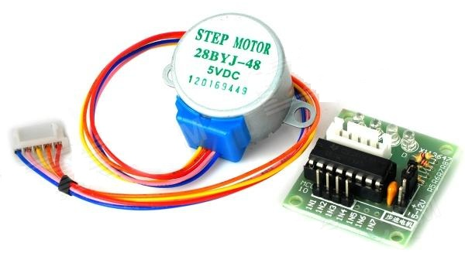
Stepper Motor
Control motion in small steps
Multiple control lines
Control can be simplified with driver chip
Often provided with gearbox

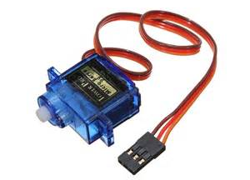
Servo
Control position
Single control wire uses special timing
Inbuilt gearbox
Hardware gives smoothest motion

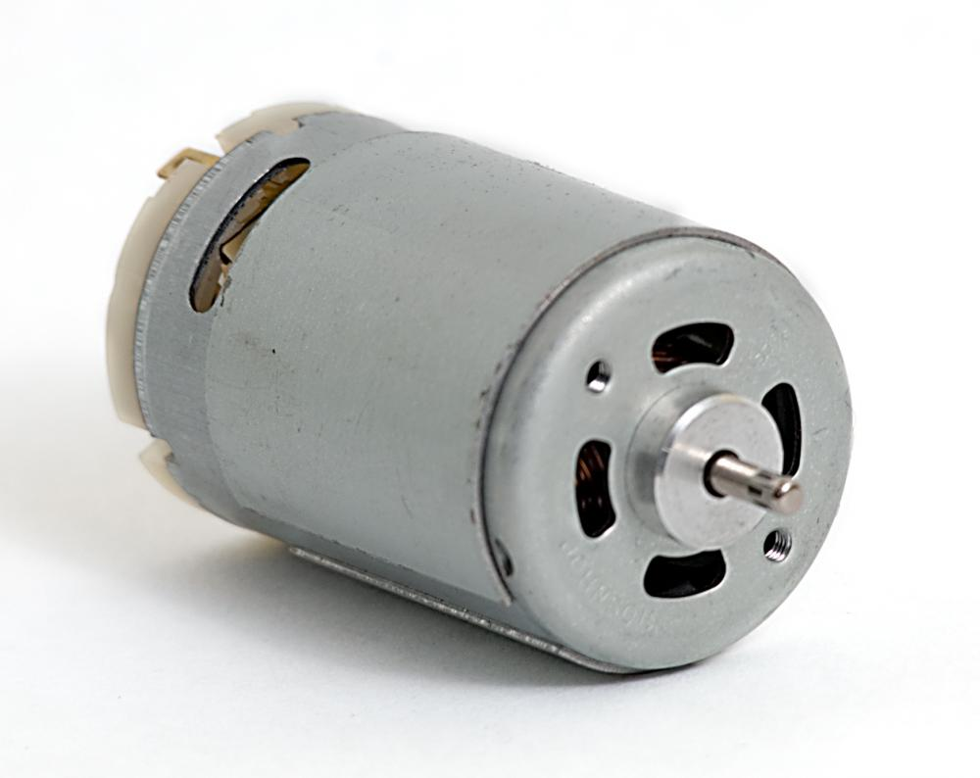
Electric Motor
Control speed (within limits)
Control direction with a “H-Bridge” circuit
Runs fast so need gearbox

